**CHANDIGARH UNIVERSITY**

**UNIVERSITY INSTITUTE OF ENGINEERING**

**DEPARTMENT OF COMPUTER SCIENCE & ENGINEERING**



|  |  |
| --- | --- |
| **Submitted By:** Sahil Kaundal  **Submitted To:** Neeru Sharma | |
| **Subject Name** | Programming Based Learning Java (Lab) |
| **Subject Code** | 20CSP-321 |
| **Branch** | Computer Science Engineering |
| **Semester** | 5th |

LAB INDEX

**NAME:** Sahil Kaundal **SUBJECT NAME:** PBLJ (Lab)

**UID:** 21BCS8197 **SUBJECT CODE:** 20CSP-321

**SECTION:** 20BCS_WM-616/A

|  |  |  |  |  |  |  |  |
| --- | --- | --- | --- | --- | --- | --- | --- |
| **Sr.No** | **Program** | **Date** | **Evaluation** | | | | **Sign** |
| **LW**  **(12)** | **VV**  **(10)** | **FW**  **(8)** | **Total**  **(30)** |
| 1. | Create an application to save the employee information using arrays. | 16/08/2022 |  |  |  |  |  |
| 2. | Design and implement a simple inventory control system for a small video rental store. | 20/08/2022 |  |  |  |  |  |
| 3. | Create a application to calculate interest for FDs, RDs based on certain conditions using inheritance. | 27/08/2022 |  |  |  |  |  |
| 4. | Create a program to set view of Keys from Java Hashtable. | 27/09/2022 |  |  |  |  |  |
|  |  |  |  |  |  |  |  |
|  |  |  |  |  |  |  |  |

**Experiment 4**

**Student Name:** Sahil Kaundal **UID:** 21BCS8197

**Branch:** BE CSE (Lateral Entry) **Section/Group:** 616/A

**Semester:** 5th **Date of Performance:** 27/09/2022

**Subject Name:** PBLJ Lab **Subject Code:** 20CSP-321

1. **Aim/Overview of the practical:**

Create a program to set view of Keys from Java Hashtable.

1. **Task to be done/ Which logistics used:**

Write the program to create an application to perform operation on Hashtable.

1. **Apparatus / Simulator Used:**

* Eclipse IDE - (Java)
* NetBeans.
* JDK-8 or any.

1. **Programs/ Code:**

package unit2;

import java.util.Enumeration;

import java.util.Hashtable;

public class Exp4 {

public static void main(String[] args) {

// TODO Auto-generated method stub

Hashtable<Integer, String> ht = new Hashtable<>();

ht.put(1, "Sahil Kaundal");

ht.put(2, "Abhinav");

ht.put(3, "Rajesh");

ht.put(4, "Omkar");

ht.put(5, "Rohit");

ht.put(6, "Raman");

Enumeration<Integer> keys = ht.keys();

Enumeration<String> values = ht.elements();

while(keys.hasMoreElements() && values.hasMoreElements()){

System.out.println("Key: "+keys.nextElement()+"\tValue: "+values.nextElement());

}

}

}

**5. Result/Output/Writing Summary:**

Here we have created the Hashtable and Enumeration and Data inserted to Hashtable with the key pairs, performed display operation.

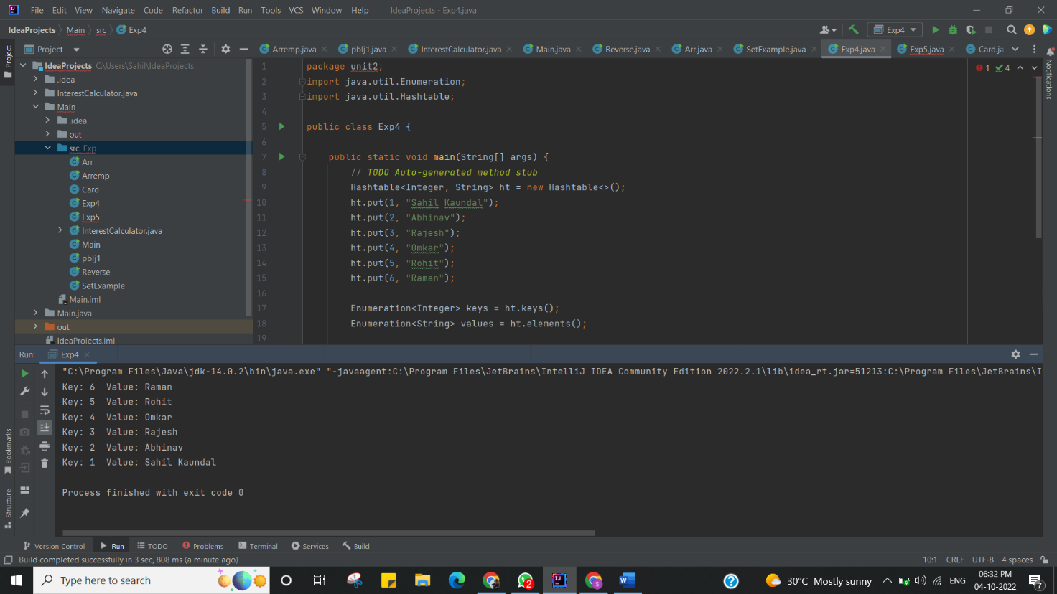

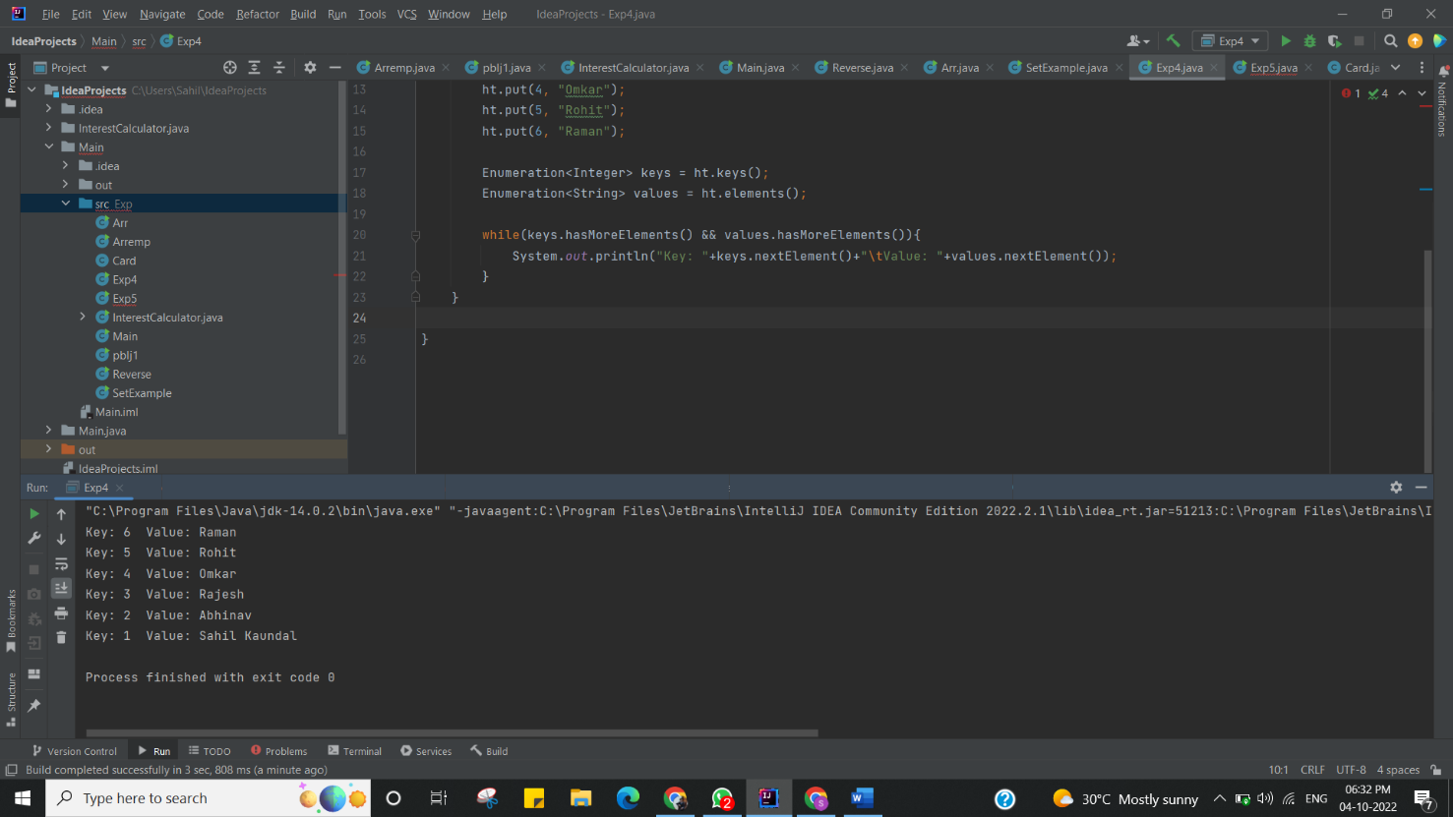

I have successfully done this program.

**Learning Outcomes (What I have learnt):**

* Learnt How to create the Hashtable and insert the values to it.
* Hashtable manipulation concept understood.
* Learnt the concept of Enumeration.
* Learnt concept of while and Hashtable iteration.
* Understood the concept of AND operator ‘&&’.

**Evaluation Grid (To be created as per the SOP and Assessment guidelines by the faculty):**

|  |  |  |  |
| --- | --- | --- | --- |
| Sr. No. | Parameters | Marks Obtained | Maximum Marks |
| 1. |  |  |  |
| 2. |  |  |  |
| 3. |  |  |  |